Adjust yaml file and map

<https://answers.ros.org/question/322919/to-understand-the-concept-of-origin-field-from-map_server/>

| Original: |
| --- |
| #changes by sam  #image: field.png  image: ros_farm_v01.png  #resolution: 0.1  resolution: .1  #origin: [-10.0, -10.0, 0.0]  origin: [-30.0, -30.0, 0.0]  negate: 0  occupied_thresh: 0.65  free_thresh: 0.196 |
|  |
| **origin** : The 2-D pose of the lower-left pixel in the map, as (x, y, yaw), with yaw as counterclockwise rotation (yaw=0 means no rotation). Many parts of the system currently ignore yaw. [link](http://wiki.ros.org/map_server#YAML_format) |
|  |
| **the origin is up to you, and the resolution is the size in meters of a pixel of your image.** |
| **Capture an image from Google Maps** |
|  |
|  |
|  |
| **So lets say the image represents a lot that is 220.69 feet wide and the image is 566 pixels wide**  **67.266312/566=0.1188**  **Resolution = 0.1188** |
| [**https://answers.ros.org/question/178972/about-resolution-on-yaml/**](https://answers.ros.org/question/178972/about-resolution-on-yaml/) |
| **Fusion 360 Export to PNG**  [**https://forums.autodesk.com/t5/fusion-360-design-validate/export-to-png/td-p/5477372**](https://forums.autodesk.com/t5/fusion-360-design-validate/export-to-png/td-p/5477372) |

Background on using satellite images in rvis:

* <https://recordnotfound.com/rviz-satellite-gareth-cross-97256>
* Construct video on mapping: <https://www.youtube.com/watch?v=K1ZFkR4YsRQ>
  + Mentioned in the video: <http://wiki.ros.org/map_server> along with map_saver
* Not a how to, but someone trying to create a self-driving golf cart: <https://neilnie.com/2019/07/09/self-driving-golf-cart-autonomous-navigation-with-the-ros-navigation-stack-part-2-path-planning/>
* <https://github.com/gareth-cross/rviz_satellite>

| **rviz_satellite setup:**  * $ cd ~/catkin_ws/src * $ git clone <https://github.com/gareth-cross/rviz_satellite.git> * $ cd ~/catkin_ws/ * $ catkin build * $ source devel/setup.bash * $ rospack find rviz_satellite #returns /home/al/catkin_ws/src/rviz_satellite * $ cd /home/al/catkin_ws/src/rviz_satellite/launch * $ roslaunch demo.launch |
| --- |

* tool which converts KML/KMZ files into my custom path format: <https://github.com/trainman419/dagny_robomagellan/blob/670a45856950bc4008bbe05aa838a7b1c70a9332/goal_list/scripts/kml2yaml.py>

Trying to use openstreet for tiles

<https://operations.osmfoundation.org/policies/tiles/>

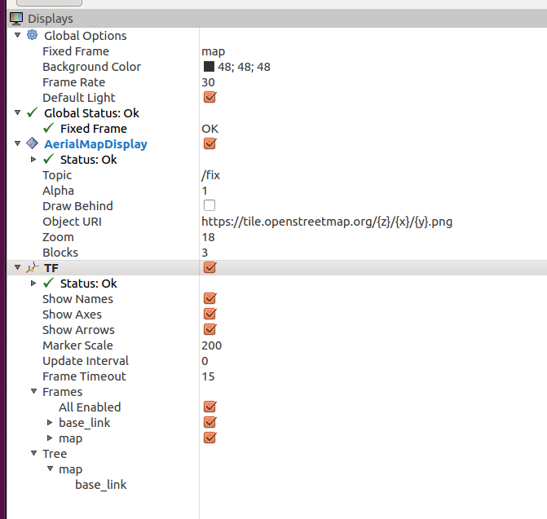

I have the same problem

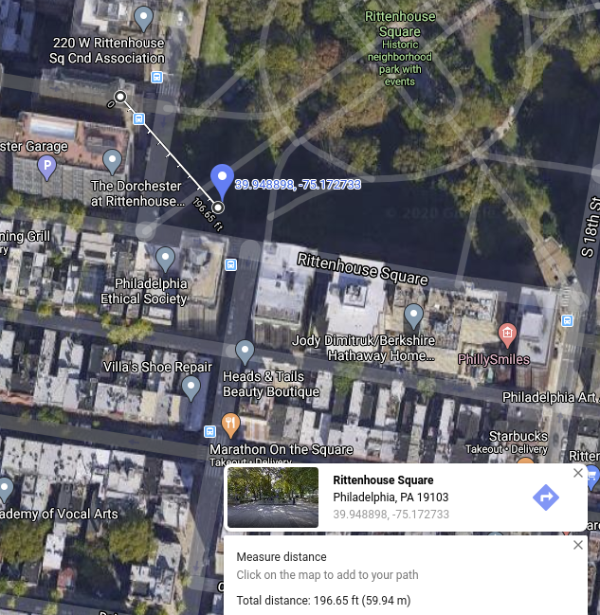

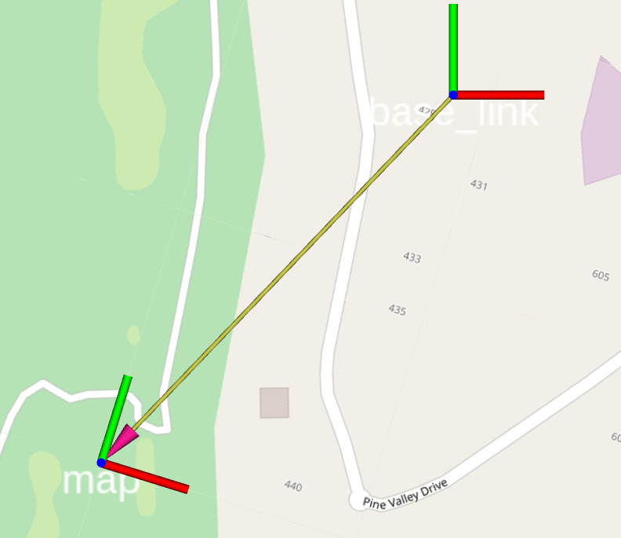

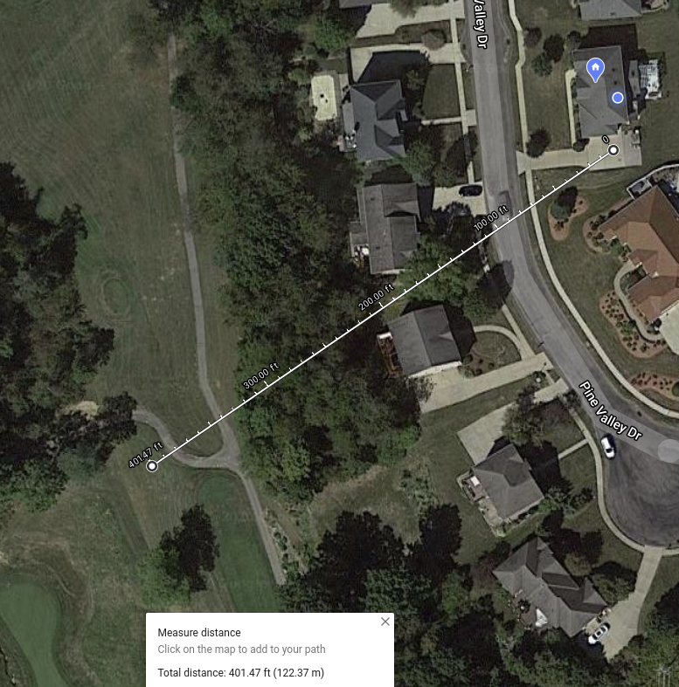

<https://www.latlong.net/c/?lat=39.951121&long=-75.189930>

<https://github.com/gareth-cross/rviz_satellite/issues/84>

|  | origin: [-10.0, -10.0, 0.0] |
| --- | --- |
|  | origin: [-30.0, -8.0, 0.0] |
|  |  |
|  |  |